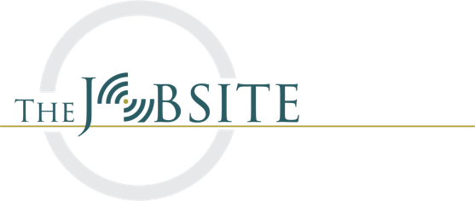
The Jobsite

The highest level of sponsorship is $10,000.00. With this level the sponsor receives:

1. A 10 x 20 tent
2. Space in the jobsite area for a vehicle and trailer with excavation equipment
3. An ample supply of meal tickets for distribution

We are creating a networking area at a large trade show, and food is an important aspect to what we want to create. We are the only area in the acres of equipment displays where someone can get a free, complete meal. We are also the only area that is dedicated to education instead of sales. We'll have pork and Mexican food trucks that will redeem the meal tickets that will bear your company’s name.

Your company will receive pre-event publicity from the PR department at the Association of Equipment Manufacturers (AEM), the owner of the Expo, and you’ll receive a complimentary $2000.00 sponsorship for The Roundtable.

A $7500.00 sponsor is provided the same benefits as the $10,000.00 sponsor except with 67% the number of meal tickets. Additionally, there is not an automatic sponsorship of The Roundtable or pre-event publicity through AEM.

A $5000.00 sponsor is provided the same benefits as the $7500.00 sponsor except only receiving a 10 x 10 tent and generic meal tickets for their attendees.

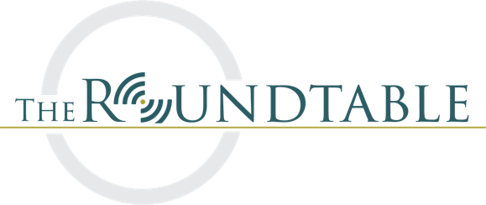
The Roundtable
$5000.00 Company logo in view of the cameras and on the arena signage, on live broadcast/video. Company listed as event sponsor in pre-event publicity and in post-event video
$3000.00 Company logo in view of the cameras and on the arena signage, on live broadcast
$2000.00 Company logo in view of the cameras but not on the arena signage, on live broadcast
$1000.00 No company logo in arena or in view of cameras, logo on live broadcast

